Troubleshoting Display EDCPSU r15

Multimeter continuity mode:
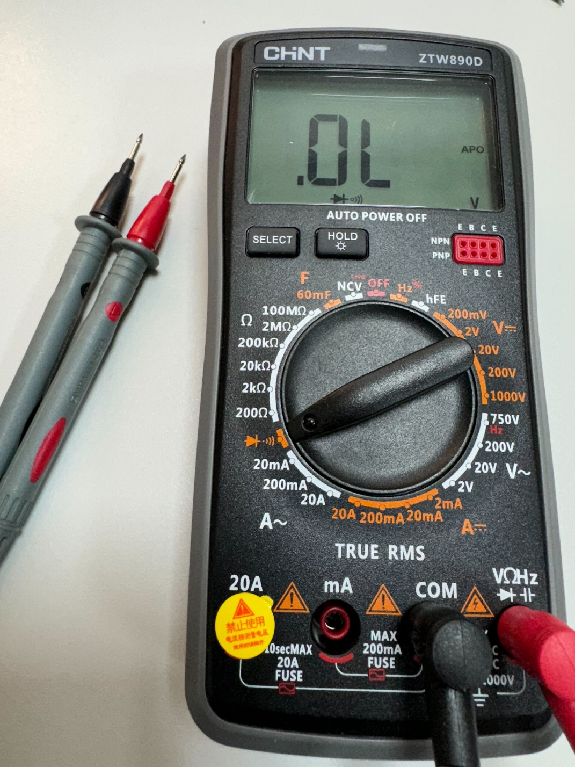
  - Pins
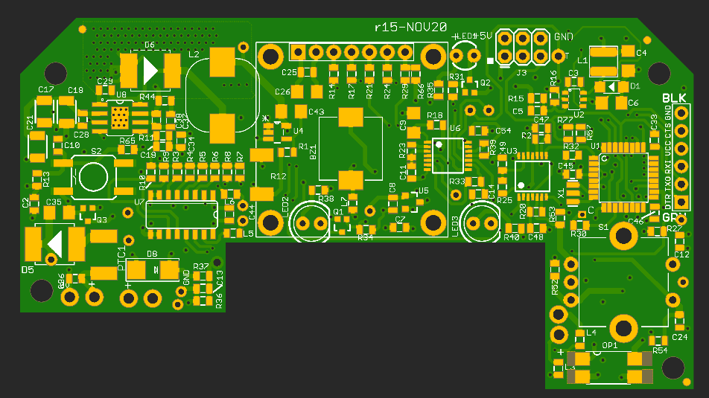
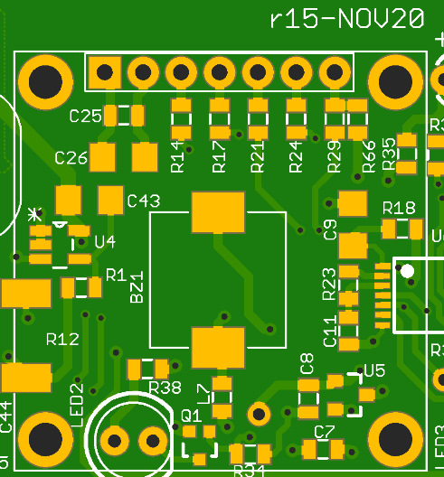
1
2
3
4
5
6
7
- GND
- VCC
- SCK
- MOSI
- DSP_RST
- MISO
- SS

- GND

- VCC


- SCK


- MOSI


- DSP_RST

4th starting from the Left

- MISO


- SS

3th starting from the Right

